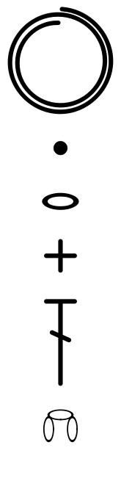

Magic circle/Adjustable ring

Slip stitch

Chain stitch

Single crochet

Chain three

Double crochet

